As you have learned the assumption of 'rational self-interest' is one of the most fundamental assumptions in economics.
The question I would like to pose to you is, Is this assumption a reasonable assumption to make? or is it possible that there are other reasons that people make the choices they do? Maybe people base a lot of their decisions on norms. Norms are implicit social rules, such as not throwing litter on the ground at school.
Consider this example and tell me whether you think that people are acting in their rational self-interest or they are behaving this way based on some social norm?
I have a friend Susan. Susan is a real fighter. She was in the Marines and now has a daughter who has cerebral palsy.
One evening Susan came to visit me and realized after a couple of glasses of wine that she better not drive home. So Susan slept on my couch and got up late the next morning. The next time I talked to Susan, I asked her whether she got to work on time?
She said, "Sure, no problem."
So I asked her how she managed it, since the wait at the freeway ramp was at least 15 minutes at that time of day.
Well Susan explained that she did the following.

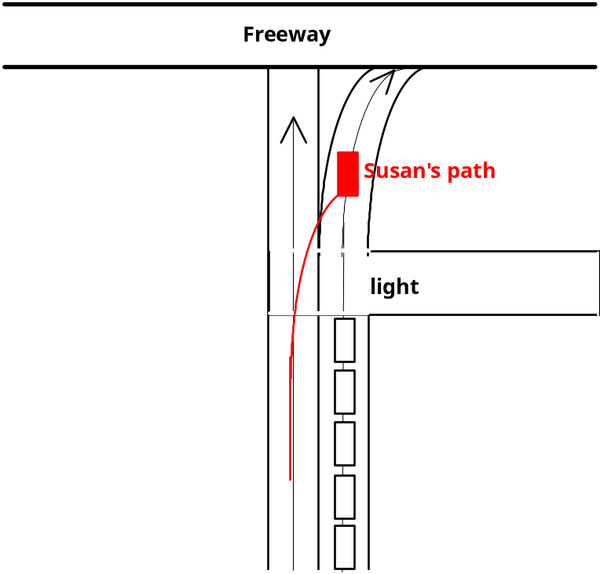

I said to Susan, "Well that was rather pushy."
She said, "No, Those people are just Stupid."

My qestion to you then is; Are those people sitting in line because of social norms or are they being rational?

